**Data Exploration and Visualization**

Conducted by: Dr. Abhishek Agarwal

Date: 09-March-2021

**Home Task 1**

Amir Ali

Generate the following plot for the Iris flower data set

1. 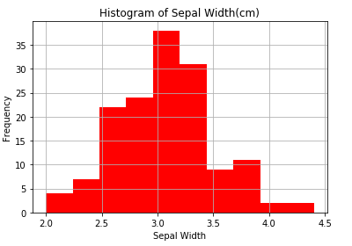**Histogram**

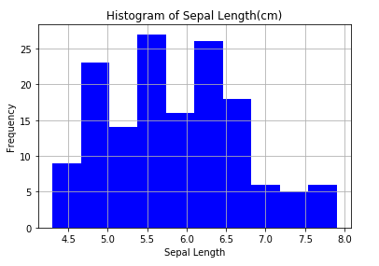

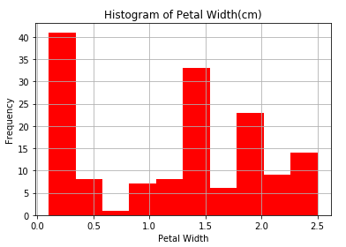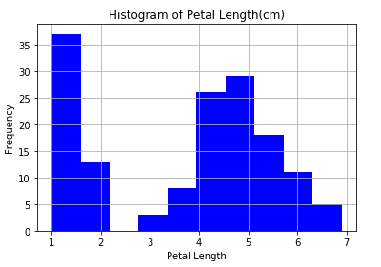

1. **Bar Plot**

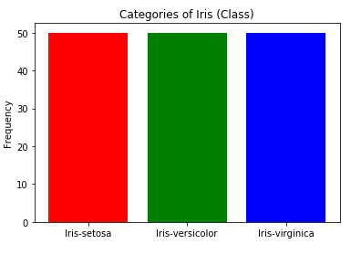

1. **Box Plot**

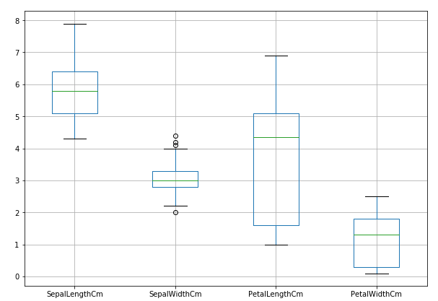

1. **Scatter Plot**

